1. Introduction

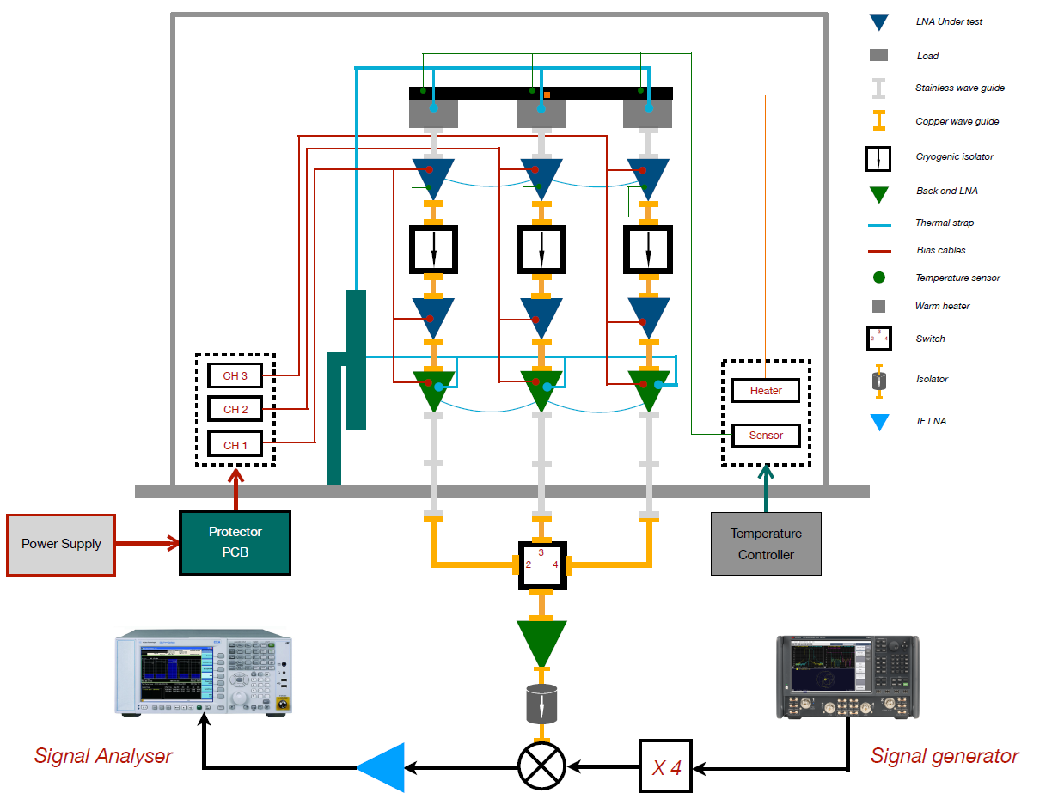This document outlines the process of setting up the Cryostat and supporting instrumentation, as seen in figure 1, for Y-Factor method noise temperature measurements in the Advanced Radio Instrumentation Group (ARIG) laboratory. Calibration of the signal generator or vector network analyser (VNA) power, and overall cryostat must be performed, the PSU must be connected correctly, and the multiplier, mixer, and switch must be powered. Once setup is complete, a measurement PC can be configured to automatically sweep bias conditions or perform single measurements using the CryoMe python application.

Figure 1 - Diagram of the Cryostat

1. Method
   1. Creating the Internal Vacuum

Once the cryostat is sealed, ensure the pump is connected to the cryostat with no leaks. Supply power to the pressure sensor. Switch on the pump and wait for the pressure to fall below 1 mbar before continuing. The pressure can be released by opening one of the seals and slowly letting air back in.

* 1. The Compressor and Cold Head

Turn on the compressor fractionally ahead of the drive unit. Requires two people. Count to 3 and turn on the compressor between count 2 and 3, and the drive unit (orange plug) on the count of 3.

* 1. PNA-X VNA Calibration & Setup

Either the PNA-X VNA or the Signal Generator can be used as a source. This section details the PNA-X VNA setup should that be chosen.

Setting the PNA-X as signal generator:

Press “preset” button in the front panel.

Using the measure menu to measure the value “R1” through measure, more, receivers.

Set the PNA-X power to -25dBm through stimulus, power, power.

Calibrate the power meter. Connect the power meter head to the calibration port. On the power meter press Cal, then Zero+Cal, the display should read approximately -65 to -70dBm.

Connect VNA Ch1 to the Power Meter.

On the VNA select ‘Cal’, ‘Power Cal’, ‘Source Cal’, (then check everything), ‘Take Cal Sweep’, and if it passes click OK, otherwise, debug until the reason for failure is found.

Add a marker to check the power of the CW tone. Usually the value of the marker is slightly higher than the value in the power setting (if the power meter reads -25dBm, the VNA will read one or two dBm higher). This is because the calibration is up to the end of the port connected to the power meter.

Switch the frequency sweep to “CW type” and set the frequency to 10GHz.

When done correctly, when set to +2dBm, the power should read +3.3 dBm +- 0.3 dBm.

* 1. Signal Generator Calibration & Setup

This section details the Signal Generator setup, should it be chosen over the PNA-X.

Calibration:

* 1. Connections

The following connections should be made and checked before proceeding:

The signal source (either the VNA or signal generator) should be connected to the IF amplifier input through the 2.9-2.4mm SMA adapter. In the ARIG lab, this will be through the adaptor into a blue cable.

The output of the multiplier should be connected to the input of the mixer using the blue cable.

The signal analyser should be connected to the output of the amplifier.

The GPIB connections between the measurement laptop, and the signal generator, signal analyser, temperature controller, and switch (NI card).

The ethernet connection between the measurement laptop and the power supply (if using the Low Noise Factory PSX supply).

* 1. Multiplier, Switch, and IF Amplifier

The multiplier should be supplied with 6 V and draw approximately 430 mA, varying between 400 to 500 mA during a measurement loop.

The waveguide switch should be supplied with 24 V and draw approximately 67 mA.

The IF amplifier should be supplied with 5.5 V and draw approximately 100 mA. When powered on, the output power measured on the spectrum analyser should increase.

* 1. Default Signal Analyser Settings

Set the centre Frequency to 75MHz and the span to 25MHz

Set a marker and then select ‘Marker’ – ‘Marker Function’ – ‘Band Power’, set the marker span to 24MHz

Set the bandwidth, select the ‘BW’ button and then set Res BW to 8MHz and the Video BW to 10Hz.

Turn on the low band preamplifier (3GHz) and set the attenuation to 0dBm. This is not included in the code so is important to do and to get right.

The power level should be around -90dBm at 0dB attenuation, -78dBm at 10dB, and -68 at 20dB.

* 1. The Lakeshore Temperature Controller

The temperature sensors should be connected as follows:

Ch6 to the cold head.

Ch7 to the cryostat load.

Ch8 to cryostat chain 1 LNA/s.

Ch9 to cryostat chain 2 LNA/s.

Ch10 to cryostat chain 3 LNA/s.

* 1. Calibration of the Cryostat

Calibration of the cryostat should be carried out before a measurement set. To do this, the cryostat should be set up with only the back end LNAs connected to the load. Then the calibrations will be automatically output after configuring the settings.yml file in the CryoMe directory, for further detail see the ReadMe in the same directory.

* 1. Thermal System Wiring

Table 1 explains the connections between the 50 Pin D sub, the 55 Way circular connector and the function of each pin.

|  |  |  |  |  |
| --- | --- | --- | --- | --- |
| 50 Pin D sub Connector | 55 way Circular Connector | RTD Number | Function | Approximate color |
| 5 | R | 6 | I+ | White/light blue |
| 6 | P | 6 | V+ | Yellow/light blue |
| 7 | N | 5 | I+ | Red/blue |
| 8 | M | 5 | V+ | White |
| 9 | L | 4 | I+ | Yellow |
| 10 | K | 4 | V+ | Red/black |
| 11 | J | 3 | I+ | Pink |
| 12 | H | 3 | V+ | Red/blue |
| 13 | x(lowercase) | 2 | I+ | Blue |
| 14 | y(lowercase) | 2 | V+ | Red |
| 15 | FF | 1 | I+ | Light blue |
| 16 | EE | 1 | V+ | Red/gray |
| 22 | z(lowercase) | 6 | V- | Purple |
| 23 | j(lowercase) | 6 | I- | Black |
| 24 | i(lowercase) | 5 | V- | Green |
| 25 | h(lowercase) | 5 | I- | Green/brown |
| 26 | g or G | 4 | V- | White/red |
| 27 | f or F | 4 | I- | Yellow/red |
| 28 | e(lowercase) | 3 | V- | White |
| 29 | d(lowercase) | 3 | I- | Yellow/light blue |
| 30 | AA | 2 | V- | Orange |
| 31 | BB | 2 | I- | Brown |
| 32 | GG | 1 | V- | Pink |
| 33 | HH | 1 | I- | Gray |
|  |  |  |  |  |
| 50 Pin D sub Connector | 55 way Circular Connector | Heater Number | Function | Approximate color |
| 47 | v(lowercase) | 2 | N.A. | Small Cable Red |
| 48 | w(lowercase) | 2 | N.A. | Small Cable Black |
| 49 | CC | 1 | N.A. | Small Cable Red |
| 50 | DD | 1 | N.A. | Small Cable Black |

*Table 1 - Letters and functions highlighted in Yellow might be different, please check.*

The temperature sensors are then connected to 25-pin connectors to the lakeshore channel selector:

Figure 2 - Scanner input connector pinout

The RTDs are related to the lakeshore channels and sensor series number according to the table2(05/10/2021). Some of these sensors have been calibrated down to 1K and other only to 10K.

|  |  |  |  |
| --- | --- | --- | --- |
| Lakeshore channel | RTD | Sensor Series number | Calibration Temp (K) |
| 5 | 1 |  | 1 |
| 6 | 2 | X167618 | 1 |
| 7 | 5 | X167616 | 10 |
| 8 | 6 | X167627 | 10 |
| 9 | 4 | X167626 | 10 |
| 10 | 3 | X167617 | 10 |

*Table 2: Sensor series and lakeshore channel number.*

Heater Connection:

|  |  |
| --- | --- |
| Heater Connection | Resistance (Ohm) |
| H1 connected to sample heater | 100 |
| H2 connected to warm-up heater | 50 |

*Table 3: heater connection (05/10/2021)*

Heater resistance at Room temp: 111 Ohm

Heater resistance at 12K: 124 Ohm

Cryostat internal sensor setting for lakeshore: DT-470 2.5V silicon diode